PSI09 AI Software Engineering Agent: Team Brief
Oct 6, 2026 · @Godwin

The problem
HNX26PSI09 (HackNEX Internal Qualifier Round, Division of CSE, Karunya Institute of Technology and Sciences) asks for an agent that changes an existing codebase and proves it broke nothing.
The agent must do four things:
- Read an existing codebase (frontend, backend, database, APIs, tests, config, docs).
- Understand how it works.
- Make a requested change or fix a bug.
- Make sure nothing that worked before is broken.
The booklet's example: "Add X feature while keeping Y workflow working." The agent finds the right files, makes the changes, runs the tests and confirms nothing broke.
Our own simple example: a bug report says "login fails when the email has capital letters." The agent searches the repo, finds the login code, lowercases the email before comparing, adds a test for it, then runs the whole test suite and reports that every test that passed before still passes.
The booklet's suggested starting point is a public repository with one documented bug fixed and working tests. The advanced tier is multi-file changes, feature additions and non-obvious bugs.

Rules and submission requirements
Two rules are specific to this problem, and breaking either one costs the most.
- Existing tests must still pass. Breaking something that worked loses major points.
- No made-up APIs or imports. The agent must use code that really exists.
General rules for every team:
- Preparation is allowed. Problem statements were shared in advance, so teams may research and set up their environment.
- AI tools are permitted, but the team must review, understand and take responsibility for the submitted work.
- Declare every external API, dataset, pre-trained model and open-source component used.
- Be able to explain the approach, demonstrate the working system and answer implementation questions at evaluation.
- Do not try to access or manipulate evaluation data or hidden test cases.
- Keep a respectful, collaborative environment. The organizers' decision on qualification is final.
What the submission must contain:
- ☐ Working system that solves the chosen problem
- ☐ Public Git repository with the full source code
- ☐ README covering what the project does, technologies, libraries and models used, how to install dependencies, how to configure and run it, and how to reproduce the demonstrated results
- ☐ Data pipeline: how input is collected, processed and passed through the system
- ☐ Core model or reasoning mechanism
- ☐ Evidence and explanation: intermediate outputs, relevant code, anything showing how it works
- ☐ At least one sample input and output, start to finish
- ☐ Scope note separating the minimum viable solution from any stretch goals
- ☐ Live demonstration (a recorded one may be allowed)
- ☐ Repository link submitted through the booklet's form by the end of evaluation
A presentation (PPT) is not necessary.

How it is judged
Hidden tests are the only item with a stated weight in the booklet: 30 points. The rest are listed without weights.
- Do the hidden tests pass? (30 points)
- Does the change work against the visible acceptance tests?
- Did the change break anything that was working?
- Did the agent understand the codebase and change the right parts?
- Is the code clean and minimal?
- Can the team explain the bug?
- Is the test code good?
Our reading (judgment, not stated in the booklet): the biggest risks are failing hidden tests on unseen repos and breaking existing tests, so reliable bug localization and regression checking matter more than interface polish.

Team, duration and constraints
A team of four first-year CSE students has a 6-hour hackathon, plus about 4 hours of solo preparation by the team lead beforehand.
Item | Detail
Team | 4 first-year CSE students
Hackathon length | 6 hours
Preparation | About 4 hours, solo, by the team lead: skeleton and structured agent loop
On the day | Lead builds the agent loop. The other three learn the resources and build the frontend. Work is split once the structure is fixed.
Operating system | Windows for all four
Coding approach | AI-assisted ("vibecoding") in a controlled environment
Git | All four are comfortable with branches
Demo | The team's own repository
Evaluation | Judges test with their own repositories and hidden test cases
Languages | Two popular languages for the MVP; the pair is not yet confirmed
LLM | Hosted API key; local models were rejected
Working method | Local workflow: clone the repo, create a new branch for the change, run the tests to check the code
The next ~2 hours are for back-and-forth discussion to settle the code structure, then prototyping and splitting the work. No fixed timeline is wanted.

Decisions so far
Four choices are settled; three are still open.
Decided:
- LLM access: use a hosted LLM through an API key. A local model (Ollama) was rejected as too slow and too weak on student laptops. The call goes through one swappable function so the provider can change later.
- Loop design: a fixed pipeline with the LLM working inside bounded steps (called Design B), not a free agent loop.
- Frontend: thin and built by the three teammates, so the lead can focus on the agent.
- Target repos: assume repositories the team has never seen, so the agent must detect the language and test command itself.
Still open:
- Which API provider and model, and who owns the key. A key must never be committed to the public repo.
- Which two languages. Python (pytest) and JavaScript (npm test) are the working assumption, not confirmed.
- The format of the task the judges give: a text bug report, an issue link or a failing test name.

Proposed solution
Code, not the model, runs every step of the pipeline. The LLM works only inside the bounded loop, and it reaches the repository only through tools.
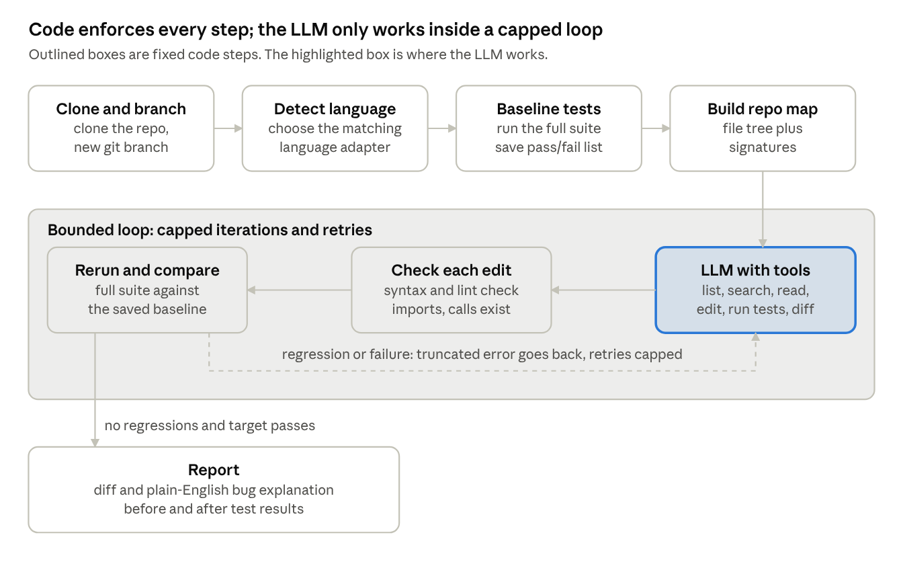
pipeline · 8 steps, 1 retry loop
Read the top row left to right, then follow the arrow down and through the loop right to left. A regression or failed test sends a truncated error back into the loop; only a clean comparison against the baseline reaches the report.
Design rules:
- Tools only. The LLM requests list_files, search_code, read_file(range), edit_file, run_tests or git_diff, and our code executes them. It never touches the repo directly.
- Orchestration is plain code. Branching, the baseline run, the regression comparison and the report are not left to the model's judgment.
- Language logic is isolated. Each language gets a small adapter with detect(), install(), run_tests() and parse_results().
- Existing tests are locked unless the task explicitly requires changing them.
- Hard caps on iterations and API spend; large files and test logs are truncated before they reach the model.
- One swappable LLM call, llm.chat(messages, tools), so the provider can change without touching the rest.
- A scripted fake LLM exercises the whole pipeline before any real model is attached.
- The API key lives in a gitignored .env file, with a blank .env.example committed to the public repo.

Two modes: bug fix and new feature
The booklet's own example is a feature request ("Add X feature while keeping Y workflow working"), so the pipeline needs a feature mode. A feature has no bug to reproduce, so that mode proves what must keep working instead.
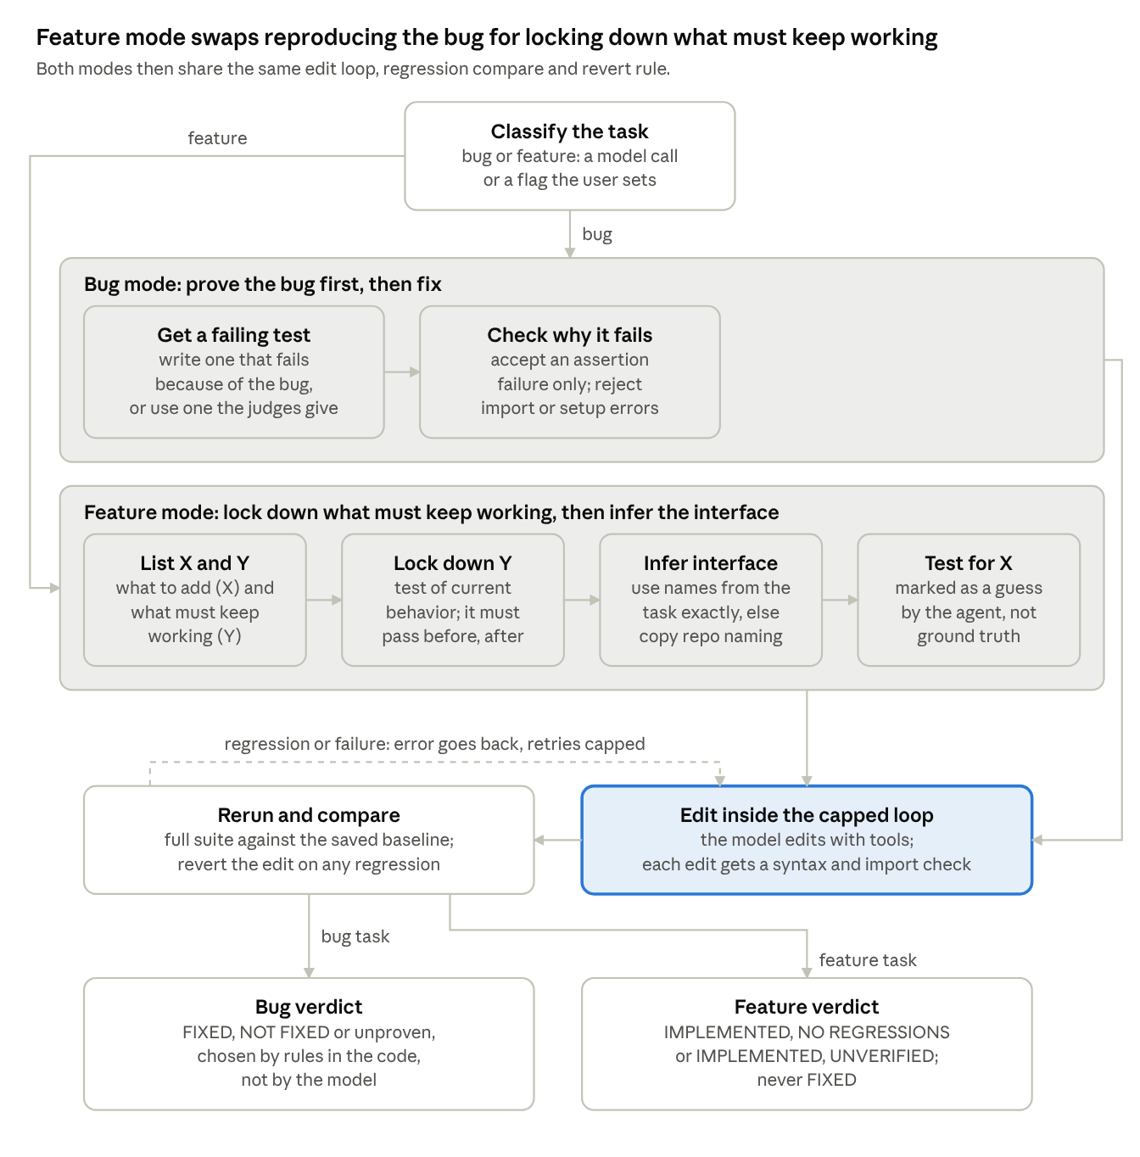
two modes · bug fix and new feature
Both modes share one edit loop, one regression compare against the baseline and one revert rule. Only the proof step before the edit and the verdict words differ.
In feature mode the acceptance test is the agent's own interpretation, so it is labeled that way. The report lists every name and signature the agent chose. Hidden tests may call different names, which makes interface guessing the main hidden-test risk in this mode.

Why it should work
These are reasoned claims, not yet tested on real repositories.
- It targets the biggest scoring items directly. Running the full test suite before and after every change produces the evidence for "hidden tests pass" and "nothing broke."
- Code enforces the risky steps, not the model. Baseline runs, branching, regression comparison and the iteration cap are ordinary code, so a weak model cannot skip them, loop forever or edit tests to make them pass.
- Narrow tools and a precomputed repo map reduce wandering. The model sees file and function names up front and can only read, search, edit and run tests.
- Existence checks target the "no invented APIs" rule. Each new import or function call is verified against the repo after every edit.
- Debugging stays separable. A scripted fake LLM tests the whole pipeline before any real model is attached, so failures can be traced to our code or to the model.
- It fits a beginner team. A fixed structure splits cleanly into modules, and every teammate can read and explain it, which the booklet requires.

Risks and open questions
The likeliest failure is environment setup on an unseen repo, not the AI edit itself.
Risk | Why it matters | Planned response
Tests will not run on Windows (missing dependencies, odd setups) | No baseline means no proof of "nothing broke" | Stop with a clear "environment failed" message instead of guessing
Repo has no tests | The baseline has nothing to compare against | Undefined; needs a decision
Flaky or slow tests | A single run can mislead the regression check | Open; consider rerunning failures before judging
Agent edits too much | Large diffs hurt the "clean and minimal" score | Smallest-diff instruction and diff size shown in the report
Agent edits existing tests to pass | Counts as breaking what worked | Existing tests locked unless the task requires changing them
Endless loops and runaway cost | A small budget can vanish in one stuck run | Caps on iterations and API spend; truncate long files and logs
Two languages in 6 hours | Each needs its own install, test and result-parsing logic | Thin per-language adapter; fall back to one language if time runs short
Rigid pipeline on unusual repos | Fixed steps may not fit every project | Keep a small free loop inside the edit step
Unknown task format from judges | Input parsing could fail on the day | Accept text and issue links; ask the organizers
API key leaks on a public repo | Bots scan GitHub for keys | Key in a gitignored .env file, with a blank .env.example committed

Questions to put to other models
The proposal is deliberately one-sided so the critiques have something concrete to attack.
- Is a fixed pipeline with a bounded LLM loop better than a free agent loop for this scoring and this team?
- What is the likeliest reason this fails on an unseen repo, and does the design handle it?
- Is a baseline-versus-after test comparison enough to claim "nothing broke," or are there gaps such as flaky tests, slow suites and test order?
- Is supporting two languages in 6 hours realistic, or should it be one language done well?
- What is missing that would score points on hidden tests, such as adding tests or multi-file changes?
- Which single component should be cut or simplified first, given the time limit?

